Factor Analysis

Notes
Output Created |  | 28-JUN-2021 14:13:41
Comments
Input | Active Dataset | DataSet63
Input | Filter | <none>
Input | Weight | <none>
Input | Split File | <none>
Input | N of Rows in Working Data File | 275
Missing Value Handling | Definition of Missing | MISSING=EXCLUDE: User-defined missing values are treated as missing.
Missing Value Handling | Cases Used | LISTWISE: Statistics are based on cases with no missing values for any variable used.
Syntax |  | FACTOR  /VARIABLES ZConfirmed ZDeaths ZRecovered  /MISSING LISTWISE  /ANALYSIS ZConfirmed ZDeaths ZRecovered  /PRINT UNIVARIATE INITIAL CORRELATION EXTRACTION ROTATION  /FORMAT SORT  /PLOT EIGEN  /CRITERIA FACTORS(3) ITERATE(25)  /EXTRACTION PC  /CRITERIA ITERATE(25)  /ROTATION VARIMAX  /METHOD=COVARIANCE.
Resources | Processor Time | 00:00:00.27
Resources | Elapsed Time | 00:00:00.25
Resources | Maximum Memory Required | 1984 (1.938K) bytes

[DataSet63]

Descriptive Statistics
 | Mean | Std. Deviation | Analysis N
ZConfirmed | .81583923 | 1.000000127 | 91
ZDeaths | 1.04360011 | 1.000000033 | 91
ZRecovered | 1.04400055 | 1.000000440 | 91

Correlation Matrix
 |  | ZConfirmed | ZDeaths | ZRecovered
Correlation | ZConfirmed | 1.000 | .995 | .968
Correlation | ZDeaths | .995 | 1.000 | .977
Correlation | ZRecovered | .968 | .977 | 1.000

Communalities
 | Raw |  | Rescaled
 | Initial | Extraction | Initial | Extraction
ZConfirmed | 1.000 | 1.000 | 1.000 | 1.000
ZDeaths | 1.000 | 1.000 | 1.000 | 1.000
ZRecovered | 1.000 | 1.000 | 1.000 | 1.000

Extraction Method: Principal Component Analysis.

Total Variance Explained
 | Component | Initial Eigenvaluesª |  |  | Extraction Sums of Squared Loadings
 | Component | Total | % of Variance | Cumulative % | Total | % of Variance
Raw | 1 | 2.960 | 98.672 | 98.672 | 2.960 | 98.672
Raw | 2 | .036 | 1.204 | 99.876 | .036 | 1.204
Raw | 3 | .004 | .124 | 100.000 | .004 | .124
Rescaled | 1 | 2.960 | 98.672 | 98.672 | 2.960 | 98.672
Rescaled | 2 | .036 | 1.204 | 99.876 | .036 | 1.204
Rescaled | 3 | .004 | .124 | 100.000 | .004 | .124

Total Variance Explained
 | Component | Extraction Sums of Squared Loadingsª | Rotation Sums of Squared Loadings
 | Component | Cumulative % | Total | % of Variance | Cumulative %
Raw | 1 | 98.672 | 1.594 | 53.144 | 53.144
Raw | 2 | 99.876 | 1.401 | 46.694 | 99.838
Raw | 3 | 100.000 | .005 | .162 | 100.000
Rescaled | 1 | 98.672 | 1.594 | 53.144 | 53.144
Rescaled | 2 | 99.876 | 1.401 | 46.694 | 99.838
Rescaled | 3 | 100.000 | .005 | .162 | 100.000

Extraction Method: Principal Component Analysis.
a. When analyzing a covariance matrix, the initial eigenvalues are the same across the raw and rescaled solution.

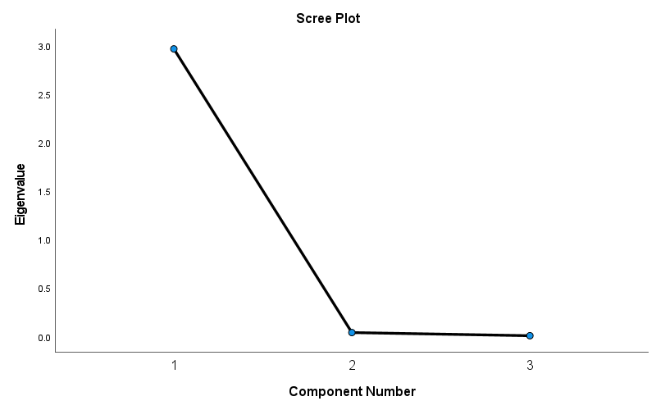

Component Matrixª
 | Raw |  |  | Rescaled
 | Component |  |  | Component
 | 1 | 2 | 3 | 1 | 2 | 3
ZDeaths | .997 | -.054 | -.046 | .997 | -.054 | -.046
ZConfirmed | .994 | -.098 | .039 | .994 | -.098 | .039
ZRecovered | .988 | .153 | .008 | .988 | .153 | .008

Extraction Method: Principal Component Analysis.ª
a. 3 components extracted.

Rotated Component Matrixª
 | Raw |  |  | Rescaled
 | Component |  |  | Component
 | 1 | 2 | 3 | 1 | 2 | 3
ZConfirmed | .793 | .608 | -.019 | .793 | .608 | -.019
ZDeaths | .765 | .641 | .066 | .765 | .641 | .066
ZRecovered | .617 | .787 | .011 | .617 | .787 | .011

Extraction Method: Principal Component Analysis.
Rotation Method: Varimax with Kaiser Normalization.ª
a. Rotation converged in 3 iterations.

Component Transformation Matrix
Component | 1 | 2 | 3
1 | .730 | .683 | .020
2 | -.683 | .730 | .000
3 | .014 | .014 | -1.000

Extraction Method: Principal Component Analysis.
Rotation Method: Varimax with Kaiser Normalization.

